EX NO : 4
DATE:
DEPLOYING A WEB APPLICATION ON AWS EC2
AIM:
To host a web application in AWS Instance.

Step 1: Launch EC2 Instance
1. Log in to your AWS Management Console.
2. In the AWS Services menu, select EC2.

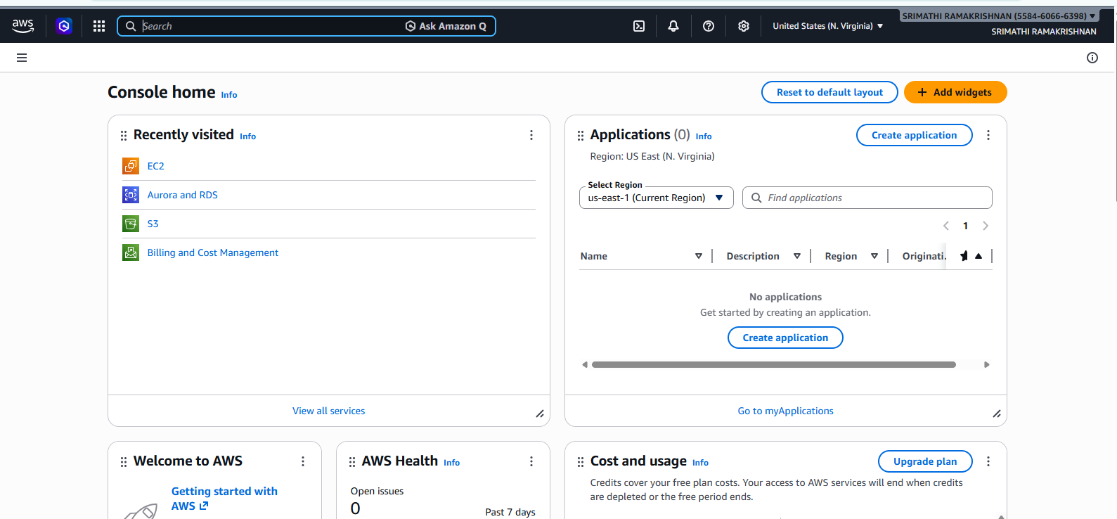

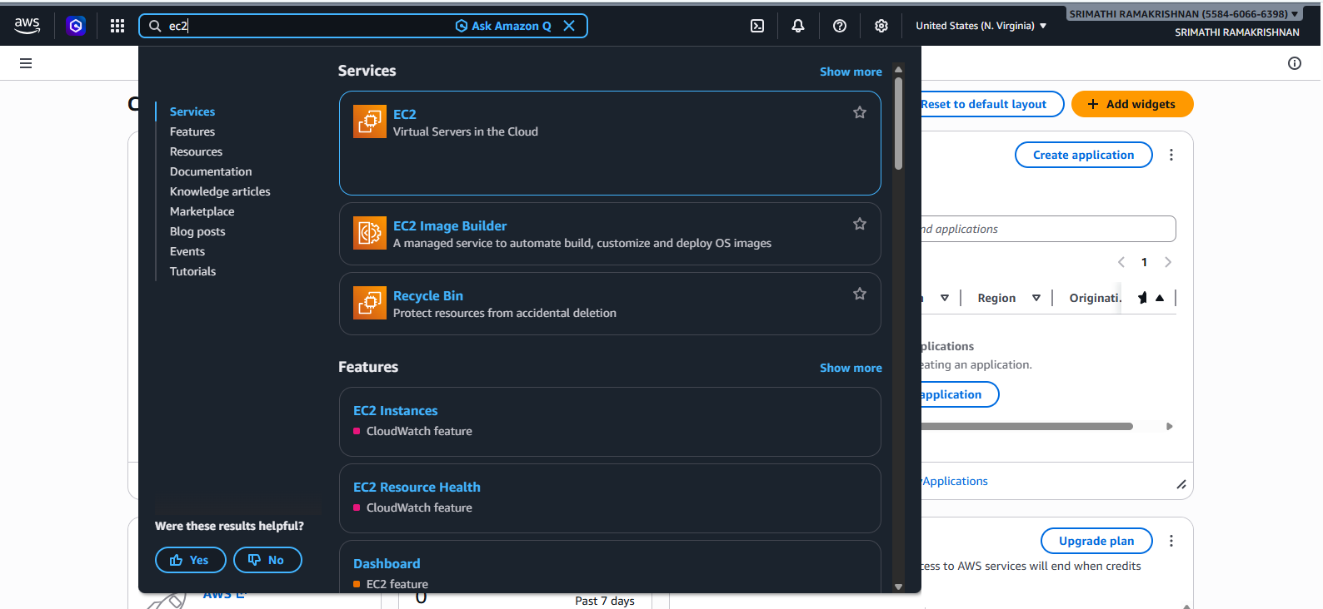

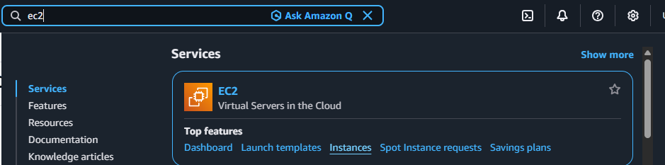

3. Click on Instances → Launch Instance.
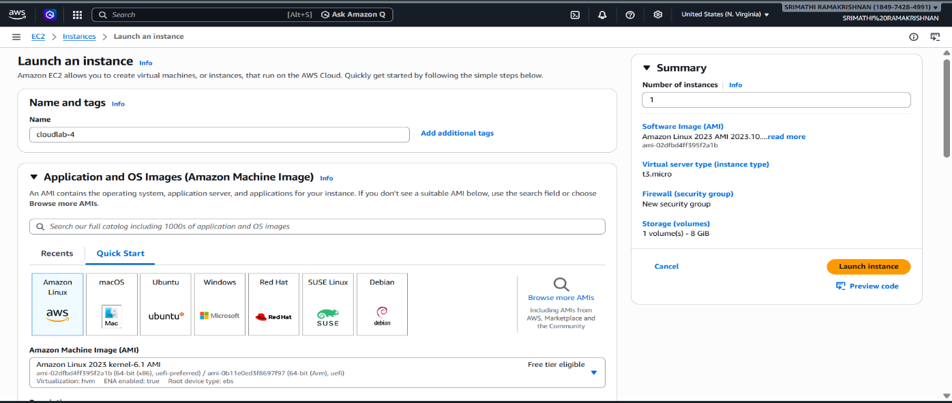

4. Select an Amazon Machine Image (AMI). Choose Amazon Linux.
5. Select the appropriate instance type (e.g., t2.micro for free tier).
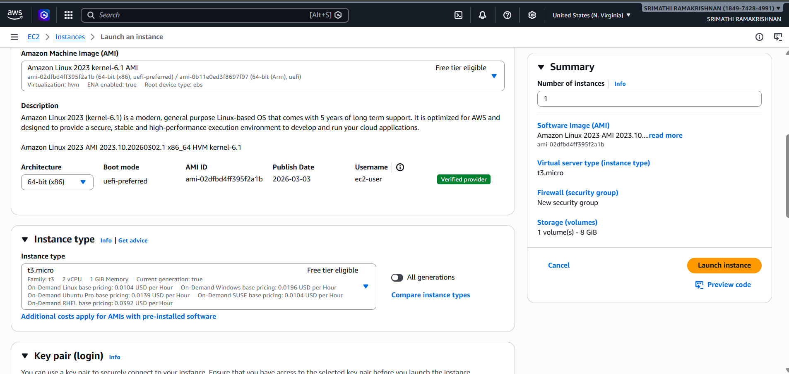
6. Create or select an existing key pair for SSH access. Download the .pem file.c

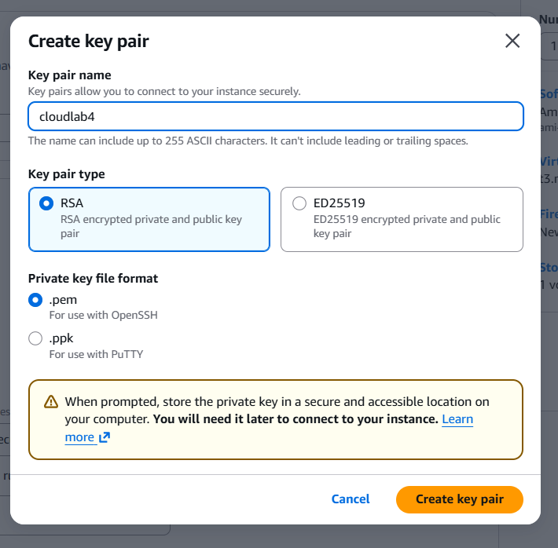

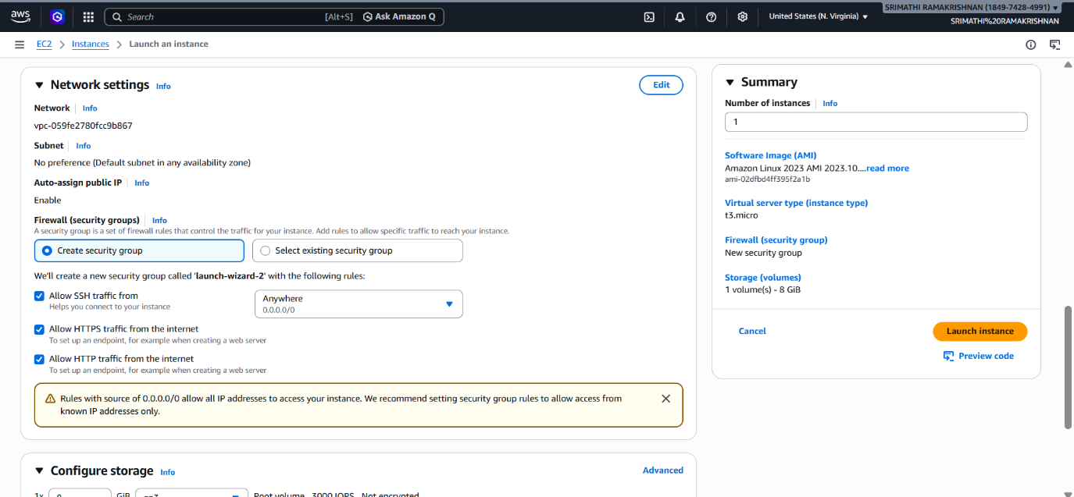

7. Configure Instance Details (leave default settings for now).
8. Add storage if needed (8 GB is sufficient for this task).
9. Configure Security Group: o Allow SSH on port 22 (for remote access). o Allow HTTP on port 80 (for website access).
10. Click Launch to start the instance.
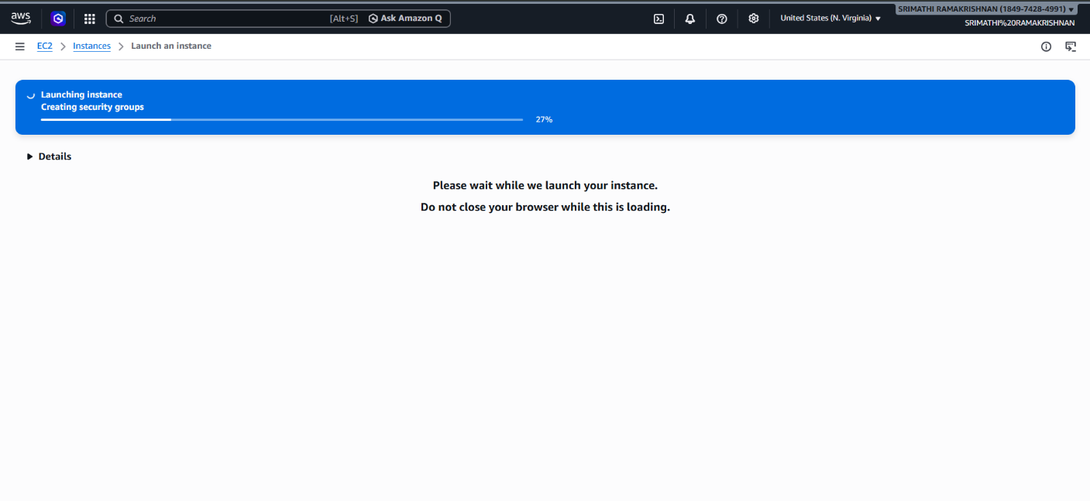

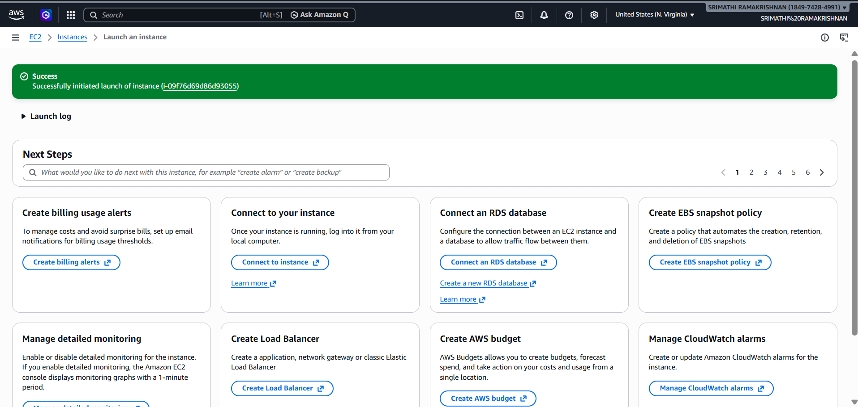

Step 2: Connect to the Instance using AWS Web Console.
- Go to EC2 Dashboard → Instances.
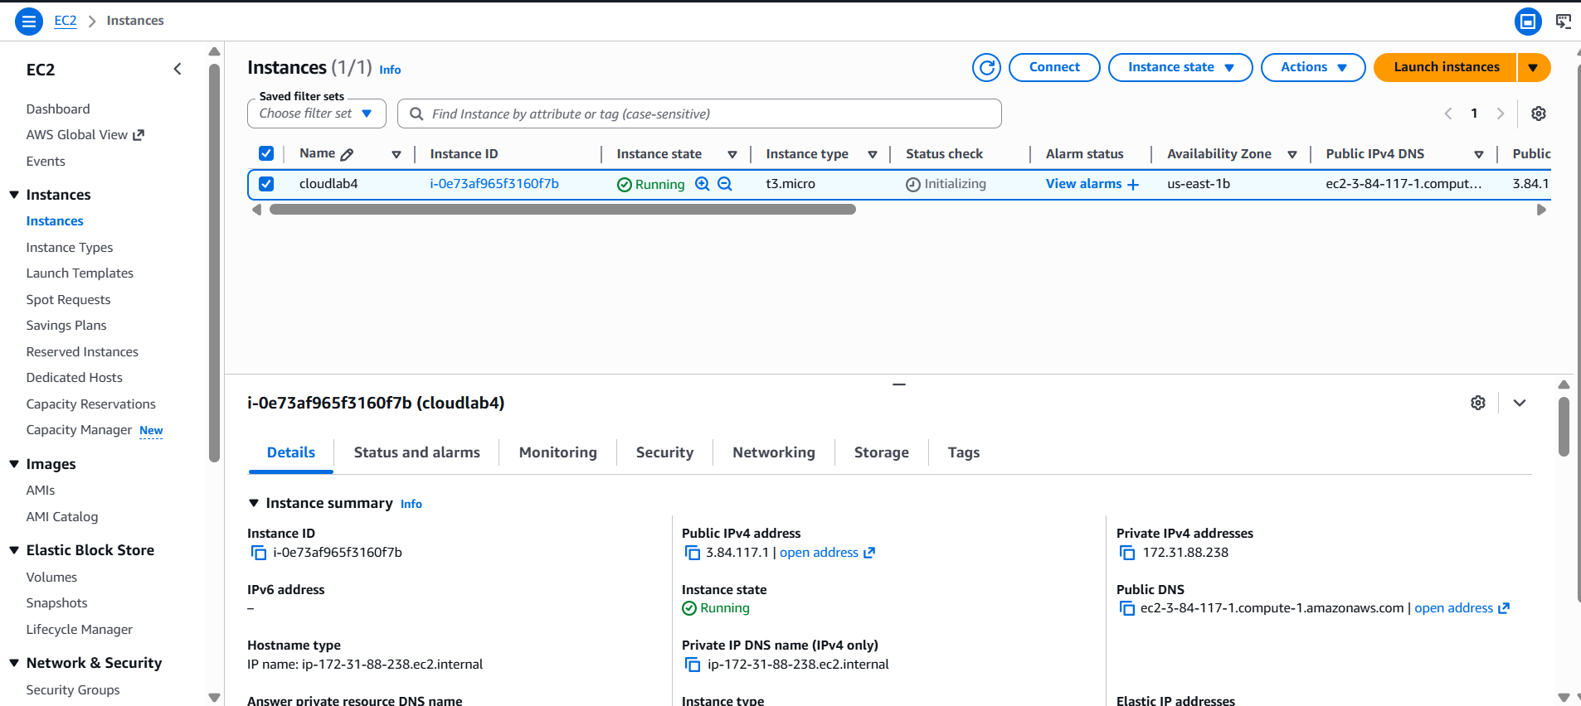

- Select your instance → Connect → EC2 Instance Connect.

- Click on Connect.

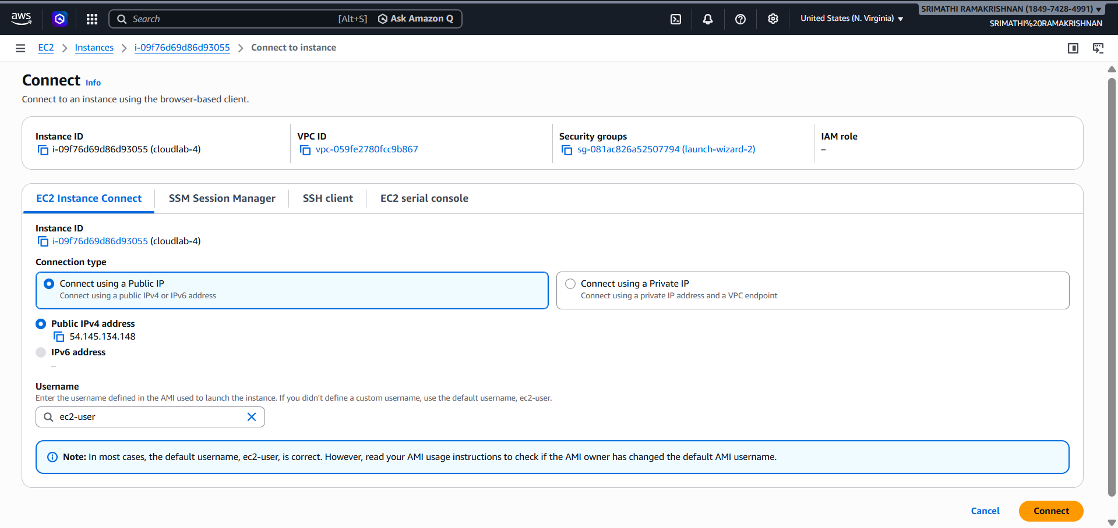
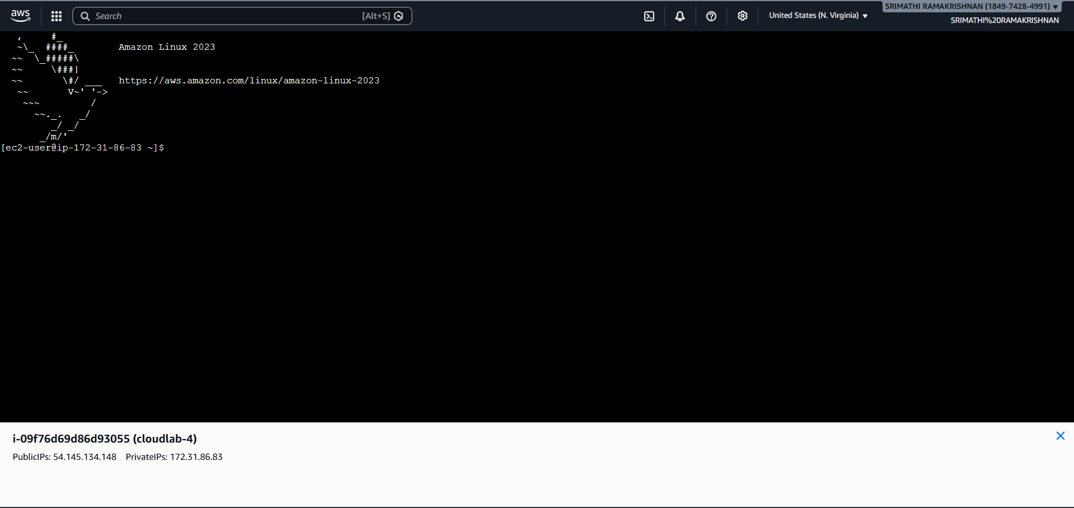

Step 3: Install Web Server and Set up Application
1. Switch to Root User:
sudo su -
2. Update packages:
yum update -y
3. Install Apache HTTP Server:
yum install -y httpd
4. Check apache Status:
Systemctl status httpd

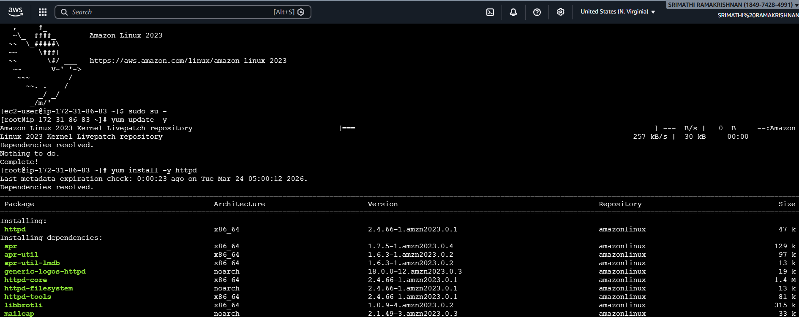
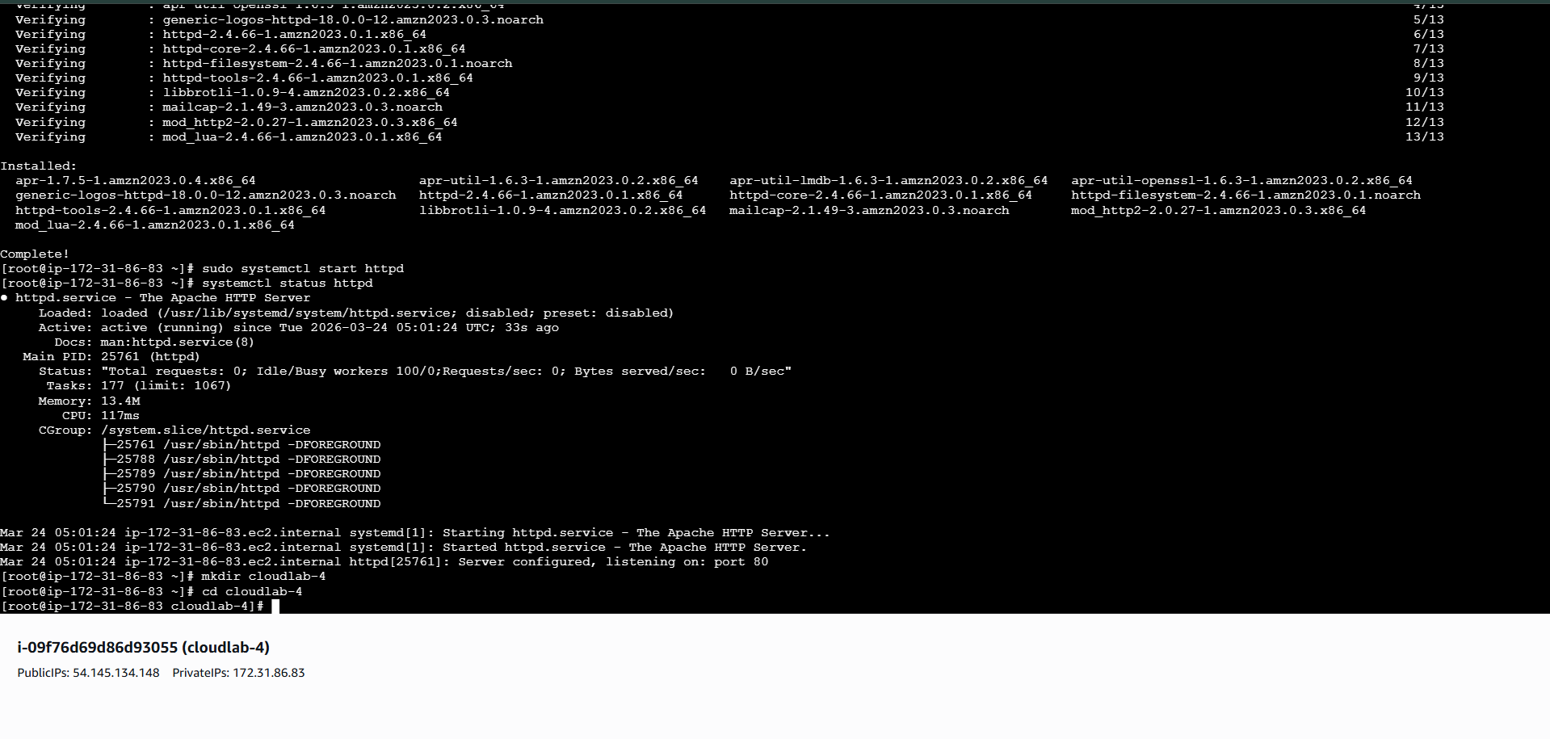

Step 4: Create a simple form page and commit it on github.

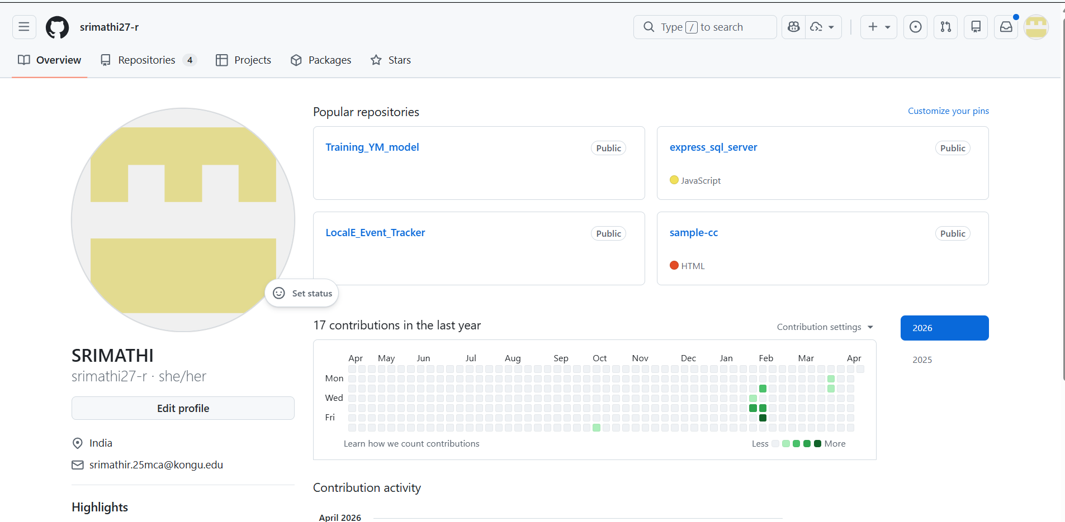

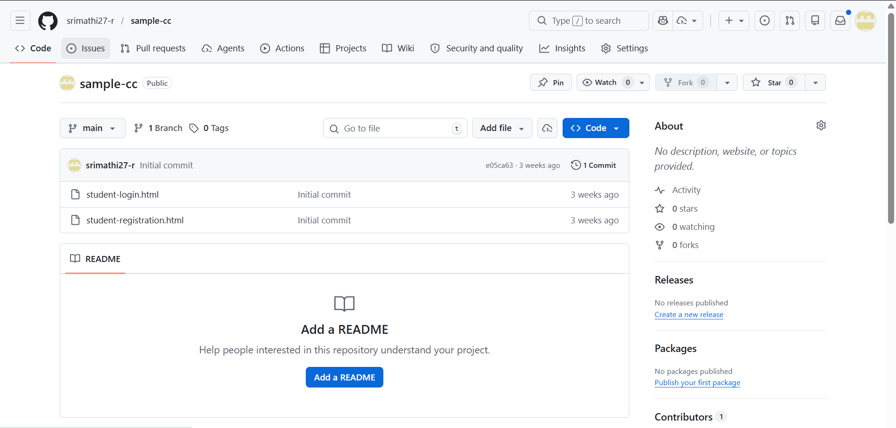

Step 5: Download and deploy a Form Page

1. Create a directory
mkdir cclab4
cd cclab4
2. Go to GitHub and copy the download link for your form page repository.
wget <GitHub repository zip file URL>
3. Install Git
sudo yum install git -y
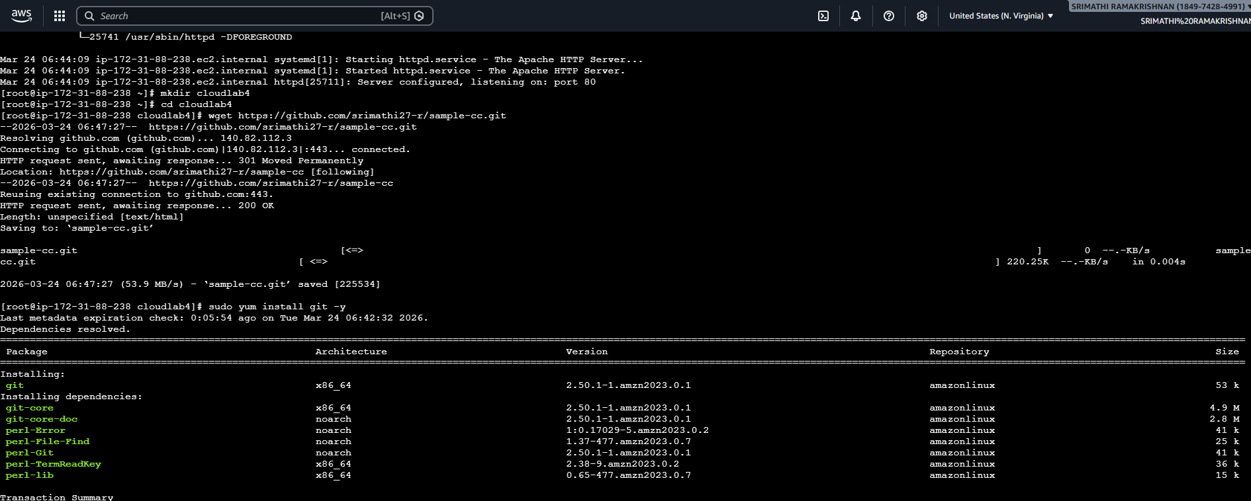
4. Clone the GitHub repository.
git clone<GitHub repository zip file URL>
5. Move to the repository
cd sample_frontend
6. Move Website files to Web directory
mv * /var/www/html/
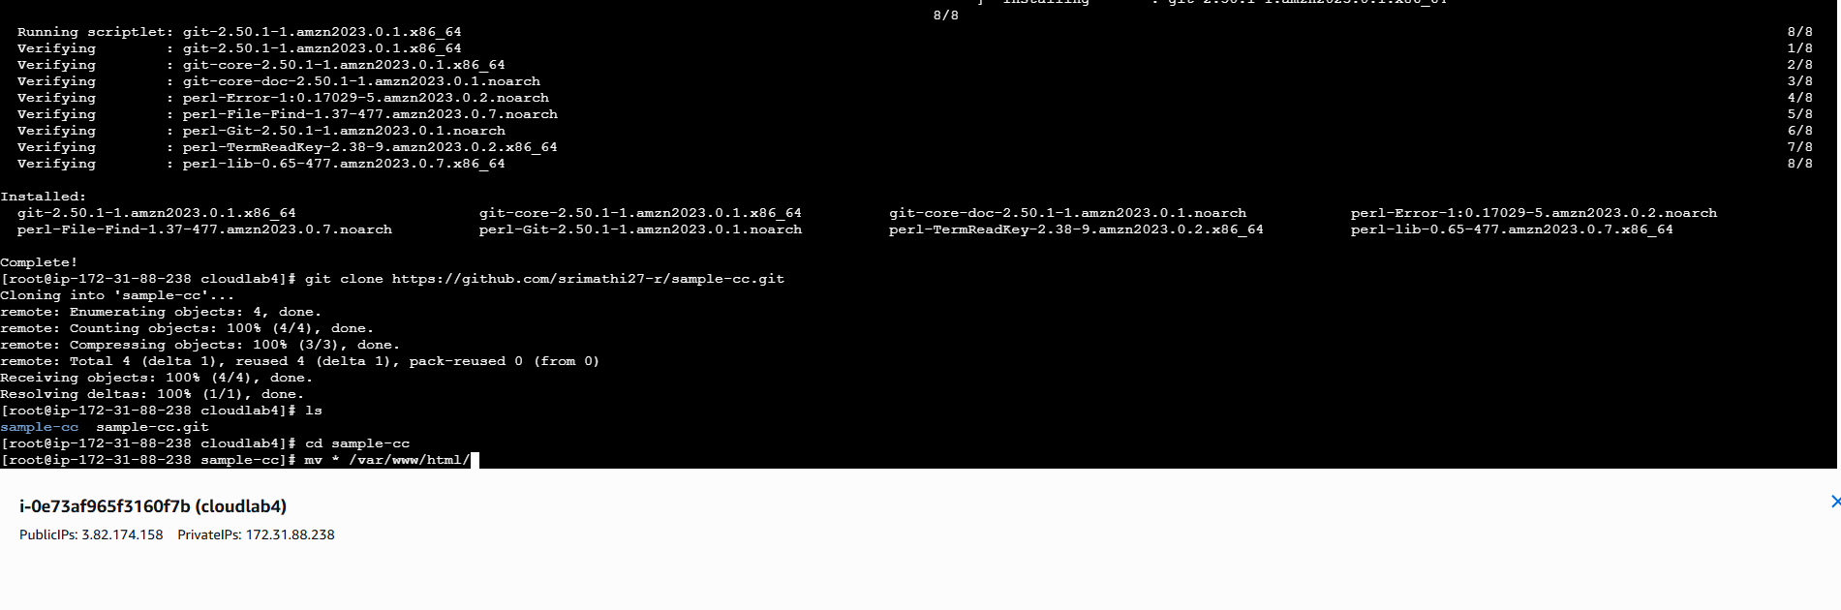
Step 6: Allow inbound rules in Security Group
Go to EC2 Dashboard -> Security Groups -> Check if the Security group of the instance has SSH, HTTP and HTTPS inbound rules otherwise add it.

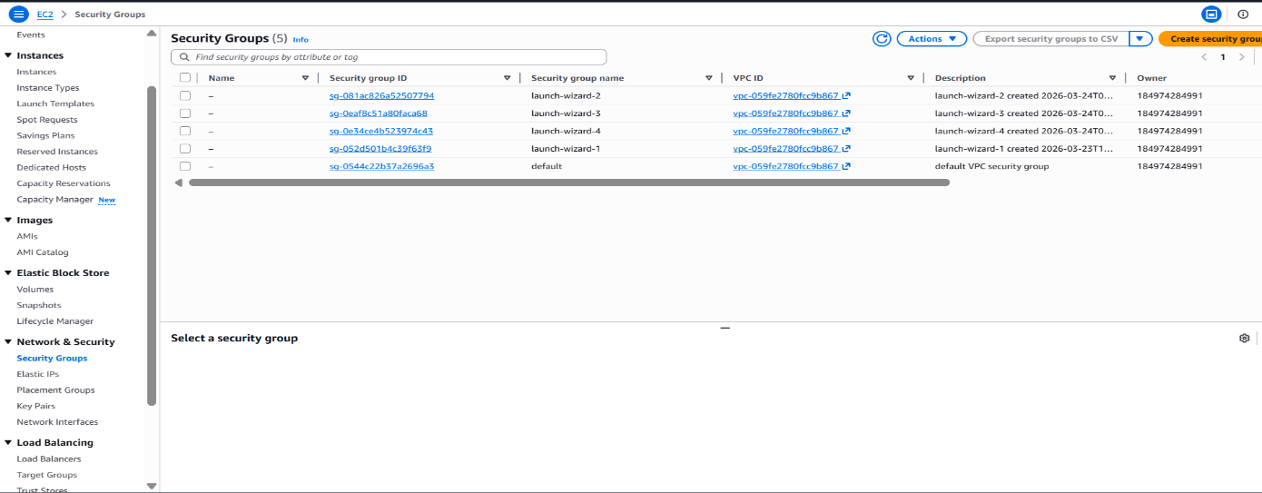
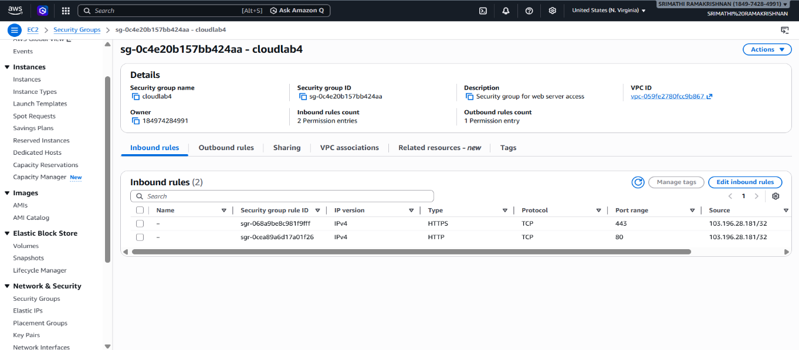

Step 7: Configure Web server
- Enable and start Apache:
systemctl enable httpd
systemctl start httpd
- Check Status:
systemctl status httpd



Step 8: Access the Web Application
1. Go to EC2 Dashboard -> Instances
2. Copy the Public IPv4 Address of your EC2 instance.
3. Open a browser and enter the following URL:
http://3.82.174.158/student-registration.html
- The deployed form page should be visible.

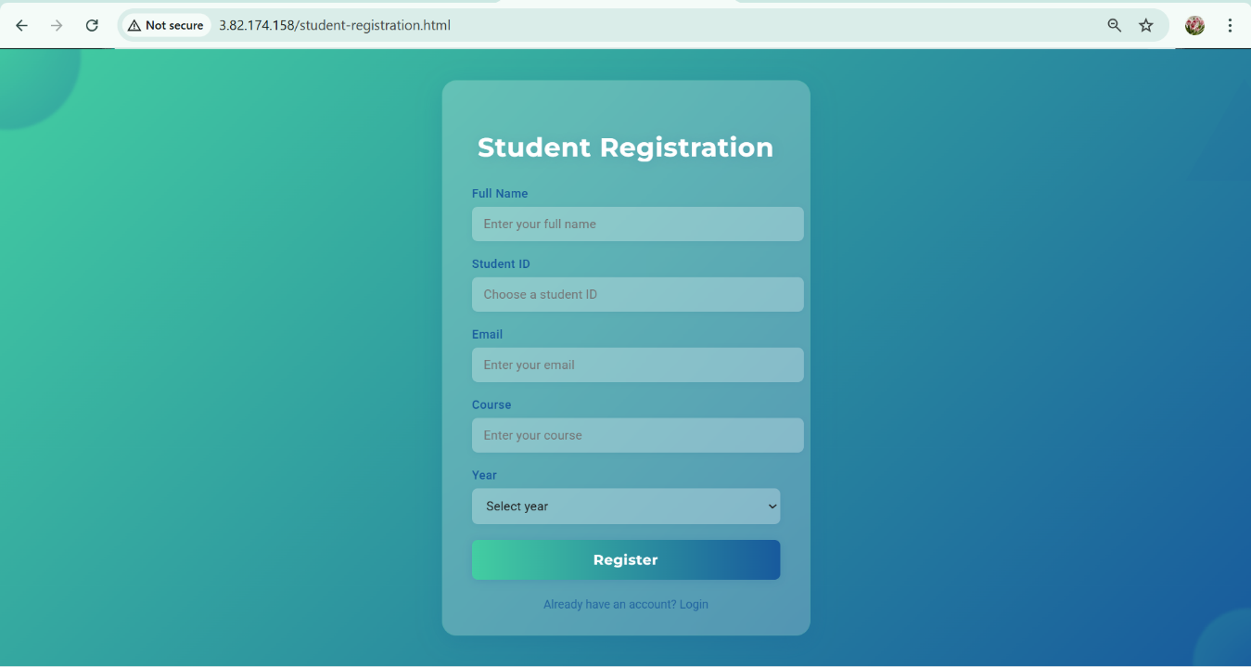

COE(30)
Record(20)
Viva(10)
Total(60)

Result:
The web application was successfully hosted on the AWS EC2 instance. It was accessed using the public IP address through a web browser.

